<Hospital Management System>
Faizan Group

Functional Specifications
Version: <1>
Date: 1/02/2018

Prepared by:Faizan,Saqib,Yaqoob,Raiyan & Zia
Revision Chart
This chart contains a history of this document’s revisions. The entries below are provided solely for illustration purposes. Those entries should be deleted until the revision/s they refer to have actually been created.
The document itself should be stored in revision control, and a brief description of each version should be entered in the Revision Control System. A brief description can be repeated in this section. Revisions need not be described elsewhere in the document, unless they explain the document.

Version | Primary Author(s) | Description of Version | Date Completed
Draft | TBD | Initial draft created for distribution and review comments | (To be decided) TBD
Preliminary | TBD | Second draft incorporating initial review comments, distributed for final review | TBD
Final | TBD | First complete draft, which is placed under change control | TBD
Revision 1 | TBD | Revised draft, revised according to the change control process and maintained under change control | TBD
Revision 2 | TBD | Revised draft, revised according to the change control process and maintained under change control | TBD
Etc. | TBD | TBD | TBD

PrefaceThe preface contains an introduction to the document. It is optional and can be deleted if desired.
Contents
New paragraphs formatted as Heading 1, Heading 2, and Heading 3 will be added to the table automatically. To update this table of contents in Microsoft Word, put the cursor anywhere in the table and press F9. If you want the table to be easy to maintain, do not change it manually.
1. Introduction 6
1.1 Project Overview 6
1.2 Problem Statement 6
1.3 Customer 6
1.4 Affected Groups 6
1.5 Assumptions 6
1.6 Dependencies/ External Systems 7
1.7 Definitions and Acronyms 7
1.8 Existing System/ Background Study 7
1.9 Reference/ Source Documents 7
Provide references to all documents that have been consulted during the analysis phase. 7
1.10 Goals 7
2. System Functions/ Functional Requirements 8
3. System Architecture 9
3.1 System Architecture Diagram 9
4. Use Case Model 10
4.1 List of Actors 10
4.2 List of Use Cases 10
4.3 Use Case Diagram 11
4.4 Use Case Buy Item 12
4.5 System Sequence Diagrams 13
4.6 User Interface/ Story Board 14
4.7 Data Dictionary 14
5. Conceptual Model 15
6. Glossary 16
7. Index 17
8. Appendices 18

List of Figures
New figures that are given captions using the Caption paragraph style will be added to the table automatically. To update this table of contents in Microsoft Word, put the cursor anywhere in the table and press F9. If you want the table to be easy to maintain, do not change it manually.
This section can be deleted if the document contains no figures or if otherwise desired.
Figure 1 System Architecture 10
Figure 2 System Level Use Case Diagram 12
Figure 3 Conceptual Model 16

Introduction
This project is about HMS in which various modules are involved such as Admin, Receptionists, Doctors Details, Patients Details, Appointments, involving Data Base. The Need of this system was to handle the hospitals management very easily and effectively. So as the data be needed carried out easily in a good manner.

Project Overview
This Project will be based on completely Object Oriented Language (JAVA) and SQL data base with fully attractive Graphical User Interface. The project will be very easy to use. The Admin have fully authority on each module admin wants to enter in. There in it will be a different use cases and a protection system such as each user (according to his position assigned) module will be firstly sing up and the unique username and password will be allotted to that specific person very easily.
Functional specifications of this project is to allow separate login patterns for different users such as Admin, Receptionists, Patients, & Doctors respectively. To allocate different ids to the patients so they can easily access their previous details and the bills information. The receptionist will be able to explain the doctors appointments details to the patient, Initially when the patient comes the receptionist will allow him to go to OPD and from there he/she will be understand the problem of the patient.

Problem Statement
The purpose of this project is to modernize our HMS there is in our state hospitals are going rough day by day. Patients are not much satisfied from the staff because there is a huge bunch of patients which they can’t handle in manual work. We want to change our hospitals management system through which every person will be felt satisfied due to this application.

Customer
Our customers in this project is a patient which will come to solve his/her diseases in a good manner the receptionist will direct him to the consulted doctor if the patient know his/her disease. We will install this application in different machines so the patient will easily access his/her profile and can be able to see the details and the calculation of bills.

Affected Groups
- Admin
- Doctors
- Receptionists
- patients

Assumptions
All the management and records will be maintain by admin. We will assume that receptionist will take care of all the appointments e.g set appointments of a patient with doctors.
Before deletion of doctor/receptionist we will assume that resignation is physically sent to admin by doctor/receptionist.
When patient is directly using HMS we will assume that patient is used to these type of systems before.

Dependencies/ External Systems
N/A

Definitions and Acronyms
HMS: Hospital Management System.

Existing System/ Background Study

Reference/ Source Documents

Goals
The proposed software product is the Hospital Management System (HMS).
The current system in use is a paper-based system. It is too slow and cannot provide updated lists
of patients within a reasonable timeframe. The intentions of the system are to reduce over-time
pay and increase the number of patients that can be treated accurately. Requirements statements
in this document are both functional and non-functional

System Functions/ Functional Requirements
End users:
- Admin
- Doctor
- Receptionist
- Patient
Programming Language
- Java
- SQL
Interface Requirement: Background of the application will be design using Photoshop, panels, buttons , radio buttons and check boxes shall be used.
System Functions:
First there will be panel consisting of two modules 1)sign up and 2)login
If end user want to access system then he/she should first create an account providing name, password ,age ,CNIC , contact ,address , qualification , designation. Then he/she will be able to login by entering their id and password.
There will be four main modules/function of this project, they are following:
- ADMIN
- RECEPTIONIST
- DOCTOR
- PATIENT
ADMIN: Admin will be the head of this management system, admin will be able to change or update in any module and their sub modules.
For example
1) Doctor detail: Admin will be able to search ,add, delete and update detail of any doctor and also will be able to see appointments .
2 ) Receptionist detail : Admin will be able to search ,add, delete and update detail of any receptionist.
3) Patient detail: Admin will be able to search, add, delete and update info of patient and he will be able to see list of indoor and outdoor patients.
4) His own profile: Admin can change his own profile and will be able to update it.

RECEPTIONIST: Receptionist will be able to deal with patient directly and send them to specific doctors or departments.
For example
1) Patient details: He will be able to search ,add new patient , add indoor patient and send them to their specific doctors and if patient doesn’t know his/her problem then he will be send to OPD where a doctor will handle patient, and also a receptionist can delete and update info of existing patients
2) Appointments: Receptionists will be able to set appointments, see list of appointments and their date and time so he can guide patients.
3) Billings: Receptionist can see billing status of each patient and he can print bill for patient.
4) His own profile: Receptionist can update their profile.

DOCTOR: Doctor can directly interact with patient for health issue and assign them specific medicines.
For example
1 ) Patient : Doctor will be able to see list of patient in a queue and appointments and their timings . Doctor can also search patient by their id’s assign to them.
2) Medicines: Doctor can see list of medicines available.

PATIENT: If a patient is mature and understand simple systems then he will be able to create his own account and access his/her bills, print bills, see previous activities and update his/her own profile.

System Attributes/ Nonfunctional Requirements
- In login panel entering 5 or more then 5 time wrong password will block user account for 30 minutes and send notification to user contact and email.
- After login system will send login notification to user contact.
- Data will be instantly updates within seconds of updation.
- Multiple Doctors, receptionists and patients can access portal.
- There will be extendable space e.g if number of patient increase form certain limit so the database will be extended to accept few more patients but still there will be limit .
- Portal will be available 24/7.
- Data of patients will be saved in database for maximum of year , e.g if a patient comes within 12 months he/she will be able to access his account and also a receptionist can guide him using his saved data.

System Architecture
Describe the system architecture, or simply provide the architecture diagram. For School system it may include web based front end, webserve , database etc. Don’t worry too much about it just give a simple diagram of a typical web based project.

System Architecture Diagram
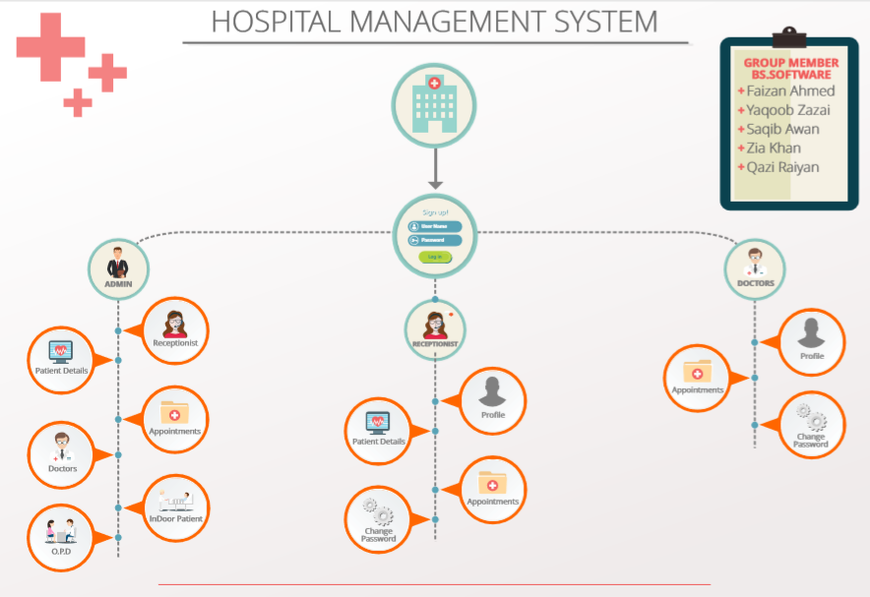

Use Case Model
Describe the following items:
- Actors & use cases
- Use case diagrams
- High level, essential use cases
No text is necessary between the heading above and the heading below unless otherwise desired.

List of Actors
Admin: He/she will be head of hospital management system.
Doctor: Directly deal with the patient .
Receptionist: Facilitate patient and doctors.
Patient: Can be a primary actor and sometime can be a secondary actor.

List of Use Cases
- Admin sign up: In order to sign up admin will create an account providing details required.
- Doctor sign up: In order to sign up doctor will create an account providing details required.
- Receptionist sign up: In order to sign up receptionist will create an account providing details required.
- Patient sign up: In order to sign up patient will create an account providing details required.
- Admin login: After creating an account admin will be able to login in to the HMS using his username and password.
- Doctor login: After creating an account doctor will be able to login in to the HMS using his username and password.
- Receptionist login: After creating an account receptionist will be able to login in to the HMS using his username and password.
- Patient login: After creating an account patient will be able to login in to the HMS using his username and password.
- Add doctor: After login to admin, admin can add doctor by giving doctor name, age, contact etc
- Delete doctor: After login to admin , admin will be able to delete any doctor from database by clicking on delete doctor button and provide id of that specific doctor.
- Update info of doctor: In this panel admin and doctor itself will be able to change details of doctors.
- Set appointments: Admin and receptionist can set appointments by giving detail of patient and set date and time.
- Check appointments: Admin, doctors and receptionist will be able to check appointments by clicking on appointments button and can check appointments stored in database.
- Add receptionist: Admin can click on add receptionist button (receptionist detail>>add receptionist) displayed in his own panel to add receptionist by giving details of receptionist.
- Delete receptionist: Admin can click on delete receptionist button to delete any receptionist by entering his id or username in search box.
- Update info of receptionist: Admin and receptionist itself can update receptionist profile (receptionist detail>>update) by clicking on update info button and providing update details and save it to database.
- Add patient (out door): Admin and receptionist can add patients to database by clicking on add patient button in their own panel (patient detail>>add patient) by providing patient detail like name, age etc.
- Add indoor patient: Admin and doctor can add indoor patient to database but for that patient must be first register as outdoor patient.
- Delete patient: Admin and receptionist can delete patient details by clicking on delete patient button in their panel (patient detail>>delete patient) by providing patient id or username.
- Update info of patient: Admin, receptionist and patient itself can change patient details by clicking on update button (patient details>>update) by providing patient id or username.
- Print or view Billing: Admin, receptionist and patient can view bills of a patients by clicking on billing button (patient details>>billing).

Use Case Diagram
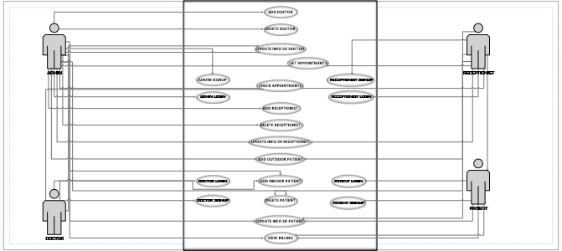

Figure 1 System Level Use Case Diagram

Expanded use cases

Section: UC1
Name: |  | Admin signup
Actors: |  | Admin
Purpose: |  | Register/create account for admin.
Description: |  | When HMS starts, admin is shown the login screen along with Sign up Screen, admin have to sign up in order to login to the application.
Cross References: |  | none
Pre-Conditions |  | none
Successful Post-Conditions |  | Admin account is successfully created.
Failure Post-Conditions |  | State of the system after completion of the operation.
Typical Course of Events
Actor Action |  |  |  | System Response
1 | Admin clicks on Sign Up Button.
 |  |  |  | 2 | Signup form is shown and step 1 is shown to the admin, waiting for the admin to enter data/info.
3 | Admin inputs first name, last name, user name, password, email, contact number, designation, qualification, post. |  |  |  | …
 |  |  |  | 4 | Admin signup information is saved to database.
 |  |  |  | 5 | Login screen is shown to the admin.
Alternative Course
Step 4: |  |  | User name already in use.

Section: UC2
Name: |  | Doctor signup
Actors: |  | Doctor
Purpose: |  | Register/create account for Doctor.
Description: |  | When HMS starts, doctor is shown the login screen along with Sign up Screen, doctor have to sign up in order to login to the application.
Cross References: |  | none
Pre-Conditions |  | none
Successful Post-Conditions |  | Doctor account is successfully created.
Failure Post-Conditions |  | State of the system after completion of the operation.
Typical Course of Events
Actor Action |  |  |  | System Response
1 | Doctor clicks on Sign Up Button.
 |  |  |  | 2 | Signup form is shown and step 1 is shown to the doctor, waiting for the doctor to enter data/info.
3 | Doctor inputs first name, last name, user name, password, email, contact number, designation, qualification, post.
 |  |  |  | 4 | Doctor signup information is saved to database.
 |  |  |  | 5 | Login screen is shown to the doctor.
Alternative Course
Step 4: |  |  | User name already in use.

Section: UC3
Name: |  | Receptionist signup
Actors: |  | Receptionist
Purpose: |  | Register/create account for Receptionist.
Description: |  | When HMS starts, Receptionist is shown the login screen along with Sign up Screen, Receptionist have to sign up in order to login to the application.
Cross References: |  | None
Pre-Conditions |  | None
Successful Post-Conditions |  | Receptionist account is successfully created.
Failure Post-Conditions |  | State of the system after completion of the operation.
Typical Course of Events
Actor Action |  |  |  | System Response
1 | Receptionist clicks on Sign Up Button.
 |  |  |  | 2 | Signup form is shown and step 1 is shown to the Receptionist, waiting for the Receptionist to enter data/info.
3 | Receptionist inputs first name, last name, user name, password, email, contact number, designation, qualification, post.
 |  |  |  | 4 | Receptionist signup information is saved to database.
 |  |  |  | 5 | Login screen is shown to the Receptionist.
Alternative Course
Step 4: |  |  | User name already in use.

Section: UC4
Name: |  | Patient signup
Actors: |  | Patient
Purpose: |  | Register /create account for Patient.
Description: |  | When HMS starts, Patient is shown the login screen along with Sign up Screen, Patient have to sign up in order to login to the application.
Cross References: |  | None
Pre-Conditions |  | None
Successful Post-Conditions |  | Patient account is successfully created.
Failure Post-Conditions |  | State of the system after completion of the operation.
Typical Course of Events
Actor Action |  |  |  | System Response
1 | Patient clicks on Sign Up Button.
 |  |  |  | 2 | Signup form is shown and step 1 is shown to the Patient, waiting for the Patient to enter data/info.
3 | Patient inputs first name, last name, user name, password, email, contact number, designation, qualification, post.
 |  |  |  | 4 | Patient signup information is saved to database.
 |  |  |  | 5 | Login screen is shown to the Patient
Alternative Course
Step 4: |  |  | User name already in use.

Section: UC5
Name: |  | Admin login
Actors: |  | Admin
Purpose: |  | Authenticate Admin.
Description: |  | HMS takes username and password as input from admin, verify credentials and give access to the application
Cross References: |  | None
Pre-Conditions |  | Admin must have to make account.
Successful Post-Conditions |  | Admin is shown home screen to use HMS.
Failure Post-Conditions |  | State of the system after completion of the operation.
Typical Course of Events
Actor Action |  |  |  | System Response
1 | Admin clicks on Login Button.
 |  |  |  | 2 | Login form is shown and step 1 is shown to the Admin, waiting for the Admin to enter data/info.
3 | Admin inputs user name and password and click on login button.
 |  |  |  | 4 | Admin signup information is verified from database.
 |  |  |  | 5 | Home screen is shown to the Admin.
Alternative Course
Step 3: |  |  | Wrong user name or password.

Section: UC6
Name: |  | Doctor login
Actors: |  | Doctor
Purpose: |  | Login to account
Description: |  | When HMS starts, application show the login screen and doctor login his account
Cross References: |  | None
Pre-Conditions |  | Doctor must have account .
Successful Post-Conditions |  | Doctor account is successfully login
Failure Post-Conditions |  | Complete
Typical Course of Events
Actor Action |  |  |  | System Response
1 | Doctor select login bar
 |  |  |  | 2 | System show the user name and password requirement .
3 | Doctor input email and password |  |  |  | …
 |  |  |  | 4 | System should verify user name and password from database .
 |  |  |  | 5 | Login button show to the doctor
6 | Doctor select login button |  |  | 7 | System show the login account
Alternative Course
Step 4: |  |  | User name already in use.

Section: UC7
Name: |  | Receptionist login
Actors: |  | Receptionist
Purpose: |  | Login to receptionist account
Description: |  | When HMS starts, application show login screen and receptionist login his account
Cross References: |  | None
Pre-Conditions |  | None
Successful Post-Conditions |  | Receptionist account is successfully login
Failure Post-Conditions |  | State of the system after completion of the operation.
Typical Course of Events
Actor Action |  |  |  | System Response
1 | Receptionist clicks on login Button.
 |  |  |  | 2 | System show the email and password
3 | Receptionist input her email and password
 |  |  |  | 4 | Receptionist information is clarified from database
5 | receptionist login to account
Alternative Course
Step 4: |  |  | User name already in use.

Section: UC8

Name: |  | patient login
Actors: |  | patient
Purpose: |  | Login to patient account
Description: |  | When HMS starts, patient login his account
Cross References: |  | None
Pre-Conditions |  | Patient must have verified account
Successful Post-Conditions |  | patient account is successfully login
Failure Post-Conditions |  | State of the system after completion of the operation.
Typical Course of Events
Actor Action |  |  |  | System Response
1 | Patient clicks on login Button.
 |  |  |  | 2 | System show email and password box
3 | patient input her email and password
 |  |  |  | 4 | patient email and password is clarified from database
 | Patient is login her account
Alternative Course
Step 4: |  |  | User name already in use.

Section: UC9
Name: |  | Add doctor
Actors: |  | Admin ,Doctor
Purpose: |  | Add doctor account
Description: |  | When HMS starts, admin will provide data info of to add doctor
Cross References: |  | None
Pre-Conditions |  | Doctor should have eligibility in hms
Successful Post-Conditions |  | doctor account is successfully created
Failure Post-Conditions |  | State of the system after completion of the operation.
Typical Course of Events
Actor Action |  |  |  | System Response
1 | admin clicks on add button
 |  |  |  | 2 | System open a dialog box waiting for admin to enter the doctor name ,email ,password ,age ,contact etc .
3 | Admin enter the doctor name ,email ,password , age ,contact etc.
 |  |  |  | 4 | System store the name in database
 |  |  |  | 5 | System show the name in doctor list
Alternative Course
Step 4: |  |  | User name already in use.

Section: UC10
Name: |  | Delete doctor
Actors: |  | Admin, doctor
Purpose: |  | Remove the doctor account
Description: |  | From HMS admin have that authority to delete any doctor
Cross References: |  | None
Pre-Conditions |  | Doctor have an account
Successful Post-Conditions |  | Doctor account has deleted .
Failure Post-Conditions |  | Doctor account is not deleted .
Typical Course of Events
Actor Action |  |  |  | System Response
1 | Admin clicks on the doctors accounts
 |  |  |  | 2 | System show all accounts and edit option.
3 | Admin select delete option
 |  |  |  | 4 | System show doctor is deleted from database ..
 |  |  |  | 5 | The list is refreshed and remaining account are show to the admin
Alternative Course
Step 3: |  |  | Wrong user name or password.

Section: UC11
Section: Main
Name: |  | Update info of Doctor
Actors: |  | Doctor and Admin
Purpose: |  | T0 update info doctor.
Description: |  | Admin and Doctor itself can update Docs profile.
Cross References: |  | Functions: R1.1, R1.2  Use Cases:
Pre-Conditions |  | Doctor has his account in Hospital system.
Successful Post-Conditions |  | That the profile of Doctor is updated successfully
Failure Post-Conditions |  | Any problem occurs in .updating Doctors profile.
Typical Course of Events
Actor Action |  |  |  | System Response
1 | Admin or Doctor open the profile of that specific Doctor..
 |  |  |  | 2 | System will open the profile of Doctor..
3 | …For updating Doc profile Admin or Doctor will press update button |  |  |  | …
 |  |  |  | 4 | System will show the update page.
 |  |  |  |  | .
 |  |  |  | 1
5 | Admin will performs an action which is necessary add Doc or update doc.
Alternative Course
Step 2: |  |  | Invalid item identifier entered. Indicate error.

Section: UC 12
Name: |  | Set appointments
Actors: |  | Admin and receptionist
Purpose: |  | Set appointments with doctor.
Description: |  | HMS takes patient detail as input from admin or receptionist , and set an appointment with doctor at specific time and date.
Cross References: |  | None
Pre-Conditions |  | Admin and receptionist should login first.
Successful Post-Conditions |  | Successfully appointment settled.
Failure Post-Conditions |  | State of the system after completion of the operation.
Typical Course of Events
Actor Action |  |  |  | System Response
1 | Admin/receptionist clicks on set appointment Button.
 |  |  |  | 2 | Set appointment form is shown and step 1 is shown to the Admin/receptionist, waiting for the Admin/receptionist to enter data/info.
3 | Admin/receptionist inputs patient name, doctor name and set date and time and click on save.
 |  |  |  | 4 | Info saved to database.
 |  |  |  | 5 | Home screen is shown to the Admin/receptionist.
Alternative Course
Step 3: |  |  | Wrong user name or password.

Section: UC13
Name: |  | Check appointment
Actors: |  | Doctor, Receptionist and admin
Purpose: |  | To check appointments.
Description: |  | Admin, Receptionist and doctor can check the appointments and update it by adding new ones.
Cross References: |  | None
Pre-Conditions |  | None.
Successful Post-Conditions |  | New appointments are added or deleted and to assign it to specific doctors.
Failure Post-Conditions |  | Any error occurs during checking the appointments or whether the record is not updated.
Typical Course of Events
Actor Action |  |  |  | System Response
1 | Doctor, Receptionist and Admin will press the button of check appointments.
 |  |  |  | 2 | System shows the page of appointments.
Alternative Course
Step 4: |  |  | User name already in use.

Section: UC14
Name: |  | Add Receptionist.
Actors: |  | Admin
Purpose: |  | To add new receptionist .
Description: |  | Admin can add new receptionist and providing his all details in his panel and save all details of receptionist in database.
Cross References: |  | None
Pre-Conditions |  | Receptionist must be eligible to registered in data base.
Successful Post-Conditions |  | Receptionist account is successfully created.
Failure Post-Conditions |  | Receptionist is ileligible and doesn’t possess the knowledge regarding this hospital management system.
Typical Course of Events
Actor Action |  |  |  | System Response
1 | Admin will click the button of add receptionist.
 |  |  |  | 2 | Signup form is shown and step 1 is shown to the Admin, waiting for the Admin to enter data/info.
3 | Admin will input all the data of new receptionist.
 |  |  |  | 4 | Receptionist is added to hospital management system data base.
 |  |  |  | 5 | Data is stored and is verified from data base
Alternative Course
Step 4: |  |  | User name already in use.

Section: UC15
Name: |  | Delete Receptionist
Actors: |  | Admin
Purpose: |  | To delete the old receptionist.
Description: |  | Admin will delete receptionist, which means receptionist is not more in hospital system.
Cross References: |  | None
Pre-Conditions |  | Receptionist should have a profile.
Successful Post-Conditions |  | The details and profile as well as data related to receptionist has been deleted.
Failure Post-Conditions |  | A problem occurs during the deleting of receptionist.
Typical Course of Events
Actor Action |  |  |  | System Response
1 | Admin click the button of delete receptionist.
2 | Admin input the receptionist id no.
3 | Admin clicks on ok button
 |  |  |  | 4 | System delete the profile of receptionist.
 |  |  |  | 5 | Home screen displayed to the admin
Alternative Course
Step 4: |  |  | User name already in use.

Section: UC16
Name: |  | Update info of receptionist.
Actors: |  | Admin, Receptionist.
Purpose: |  | To update the profile of current receptionist.
Description: |  | Admin as well as receptionist can update receptionist profile which means to add more details.
Cross References: |  | None
Pre-Conditions |  | Receptionist has already a profile.
Successful Post-Conditions |  | The profile has been updated.
Failure Post-Conditions |  | The recent details of receptionist is not there or any issue occurs during updating the receptionist profile.
Typical Course of Events
Actor Action |  |  |  | System Response
1 | Admin or Receptionist will click the update receptionist button.
 |  |  |  | 2 | Details form is shown and step 1 is shown to the Admin/Receptionist, waiting for the Admin/Receptionist to enter data/info.
3 | Admin/Receptionist inputs updated details and clicks on save button
 |  |  |  | 4 | System records the response in data base and the data is verified from it
 |  |  |  | 5 | Home screen displays to the admin/receptionist
Alternative Course
Step 3: |  |  | Wrong user name or password.

Section: UC17
Name: |  | Adding patient (Outdoor)
Actors: |  | Admin and Receptionist
Purpose: |  | Adding details of outdoor patient
Description: |  | HMS takes the name and full details of patient and add the patient to the data base and give easily access to give details about outdoor patient to admin and receptionist
Cross References: |  | None
Pre-Conditions |  | None
Successful Post-Conditions |  | Outdoor Patient successfully added to data base.
Failure Post-Conditions |  | Not knowing the complete details of the outdoor patient.
Typical Course of Events
Actor Action |  |  |  | System Response
1 | Admin and receptionist click on add new patient
 |  |  |  | 2 | Details form is shown and step 1 is shown to the Admin/Receptionist, waiting for the Admin/Receptionist to enter data/info.
3 | Admin/Receptionist inputs first name, last name, user name, password, contact number, designation, address, qualification, post of patient.
4. | Admin/Receptionist click on ok button |  |  | 5 | System will save the info in data base and verified from the system.
 |  |  |  | 6 | Home screen displayed to the admin/receptionist
Alternative Course
Step 3: |  |  | Missing some info

Section: UC18
Name: |  | Adding patient (Indoor)
Actors: |  | Admin and Doctor
Purpose: |  | Adding details of Indoor patient
Description: |  | HMS takes the name and full details of patient and add the patient to the data base and give easily access to give info about Indoor patient to admin and Doctor.
Cross References: |  | None
Pre-Conditions |  | Indoor patient must be firstly registered in outdoor patients list.
Successful Post-Conditions |  | Indoor Patient successfully added to data base.
Failure Post-Conditions |  | Not registered firstly at outdoor patients list.
Typical Course of Events
Actor Action |  |  |  | System Response
1 | Admin and Doctor click on add new Outdoor patient
 |  |  |  | 2 | Details form is shown and step 1 is shown to the Admin/Doctor, waiting for the Admin/Doctor to enter data/info.
3 | Admin/Doctor inputs first name, last name, user name, password, contact number, designation, address, qualification, post of patient, Disease.
4. | Admin/Doctor click on ok button |  |  | 5 | System will save the info in data base and verified from the system.
 |  |  |  | 6 | Home screen displayed to the admin/Doctor
Alternative Course
Step 3: |  |  | Missing some info.
Section: UC19
Name: |  | Delete Patient
Actors: |  | Admin & Receptionist
Purpose: |  | To remove patient from data base
Description: |  | HMS takes the id no. of patient and can delete the patient from the data base
Cross References: |  | None
Pre-Conditions |  | Patient must be registered in database
Successful Post-Conditions |  | Patient successfully deleted from the database
Failure Post-Conditions |  | State of the system after completion of the operation.
Typical Course of Events
Actor Action |  |  |  | System Response
1 | Admin/Receptionist enter the id no. in the data base of patients.
2. | Admin/Receptionist click on delete the patient button. |  |  | .
 |  |  |  | 3 | The patient will be remove from the database.
 |  |  |  | 4 | Home screen is display to the Admin/Receptionist.
Alternative Course
Step 3: |  |  | Wrong clicking on button.

Section: UC20
Name: |  | Update info of patient
Actors: |  | Admin/Receptionist/Patient
Purpose: |  | Modify the info of patient
Description: |  | HMS takes the info needed for modification of info of patient and update it in the database record.
Cross References: |  | None
Pre-Conditions |  | Patient must be registered in database
Successful Post-Conditions |  | Patient info successfully update in database
Failure Post-Conditions |  | State of the system after completion of the operation.
Typical Course of Events
Actor Action |  |  |  | System Response
1 | Admin/Receptionist/Patient clicks on update info of patient button.
 |  |  |  | 2 | Detail form is shown to the Admin/Receptionist/Patient and waiting for admin/Receptionist/Patient to enter the info
3 | Admin/Receptionist/Patient enter the update info in the form and clicks on save button
 |  |  |  | 4 | Updated record successfully added to the database and is verified from database.
 |  |  |  | 5 | Home screen is shown to the Admin/Receptionist/Patient
Alternative Course
Step 3: |  |  | Wrong Details

Section: UC21
Name: |  | Print or view billing
Actors: |  | Admin/Receptionist/Patient
Purpose: |  | Printing or viewing the billing of patient
Description: |  | HMS print or displays the total bill of patient
Cross References: |  | None
Pre-Conditions |  | Patient must be registered in database
Successful Post-Conditions |  | Patient bill successfully view/print from database
Failure Post-Conditions |  | State of the system after completion of the operation.
Typical Course of Events
Actor Action |  |  |  | System Response
1 | Admin/Receptionist/Patient enter the id no. of patient.
2 | Admin/Receptionist/Patient clicks on billing button
 |  |  |  | 3 | Total bill of the patient shows on the screen
4 | Admin/Receptionist/Patient clicks on print bill button
 |  |  |  | 5 | Total bill printed to the Admin/Receptionist/Patient
 |  |  |  | 6 | Home screen is display to the Admin/Receptionist/Patient
Alternative Course
Step 3: |  |  | Printing fault

System Sequence Diagrams
UC1: ADMIN SIGNUP
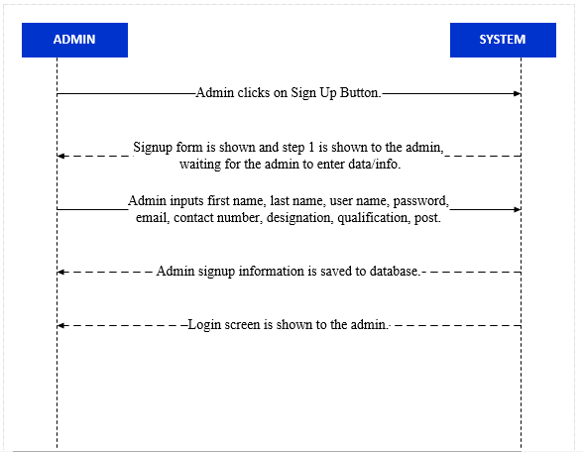

UC2: DOCTOR SIGNUP
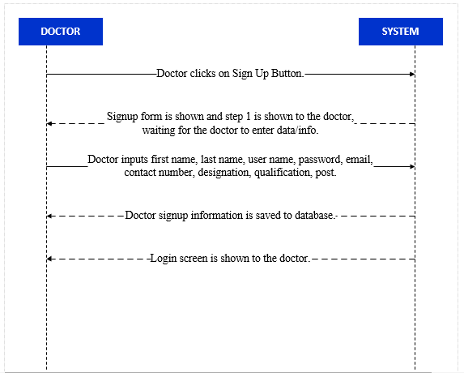
UC3: RECEPTIONIST SIGNUP
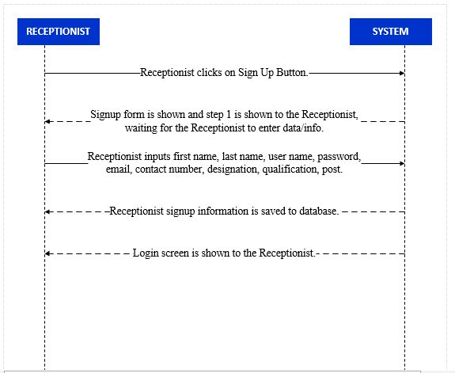
UC4: PATIENT SIGNUP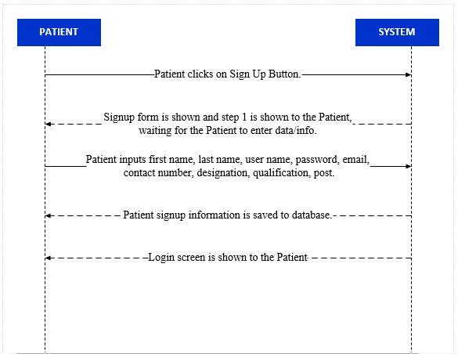
UC5: ADMIN LOGIN
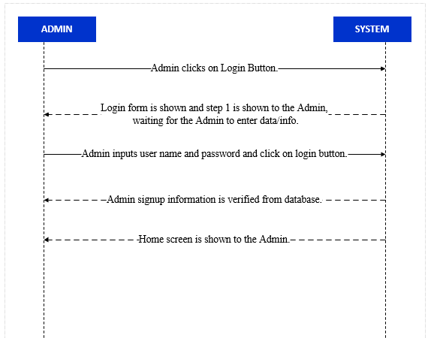
UC6: DOCTOR LOGIN
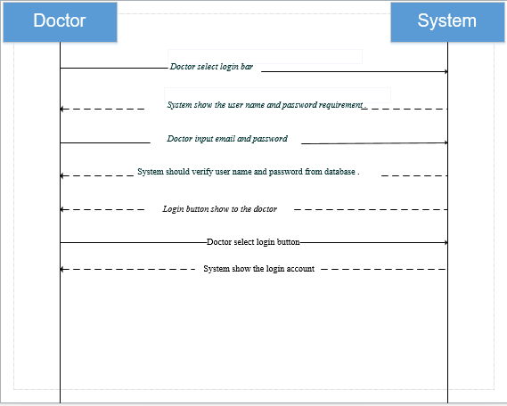
UC7: RECEPTIONIST LOGIN
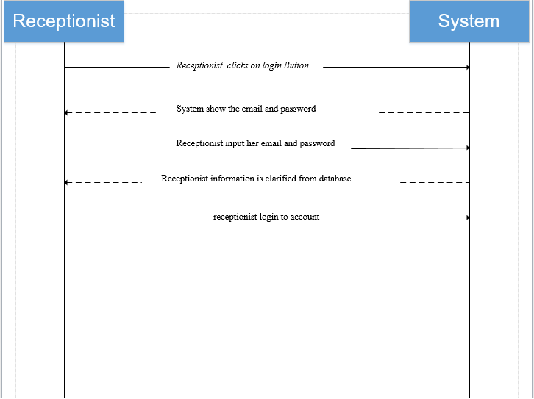
UC8: PATIENT LOGIN
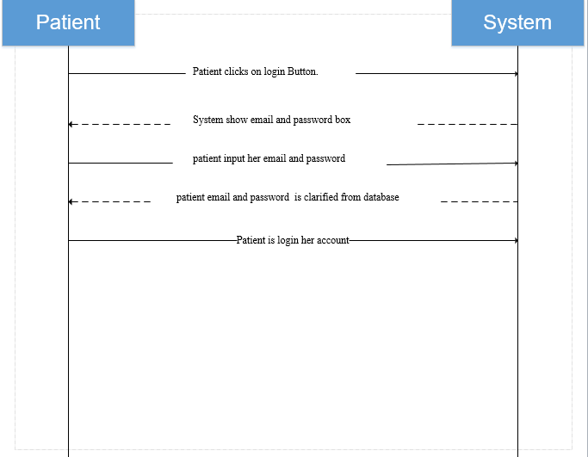
UC9: ADD DOCTOR
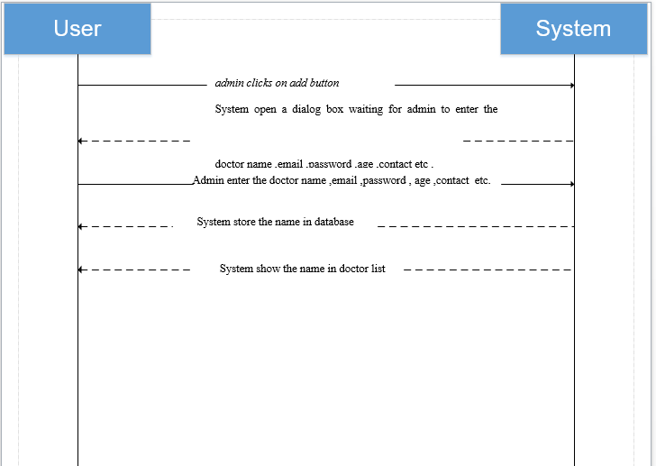
UC10: DELETE DOCTOR
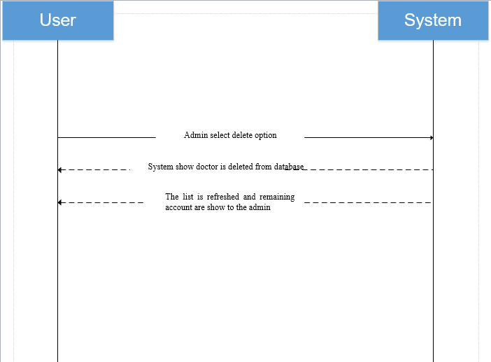

UC 11:Update info of doctor
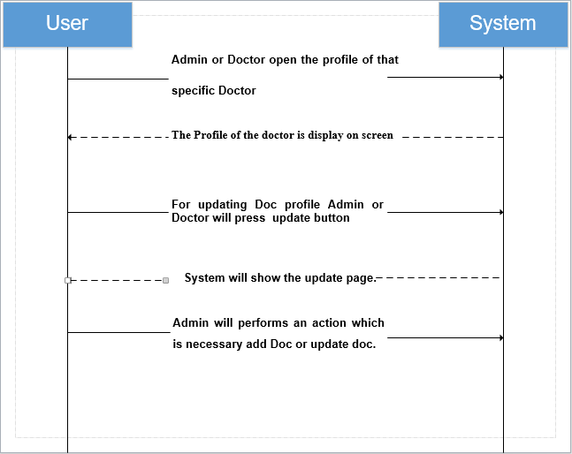
UC 12: Set Appointment
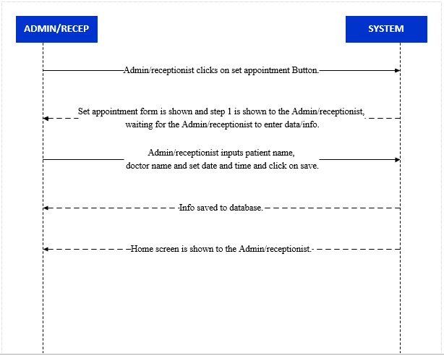

UC13: CHECK APPOINTMENT

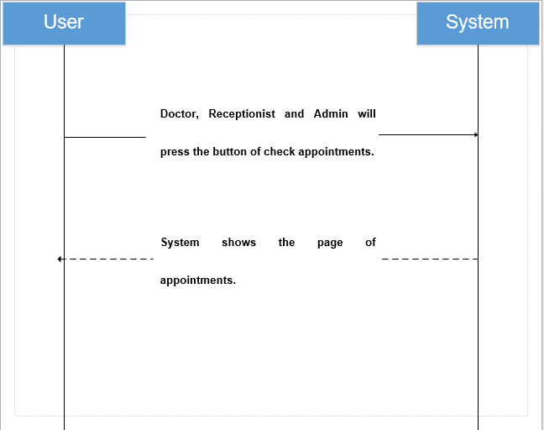

UC 14: Add receptionist 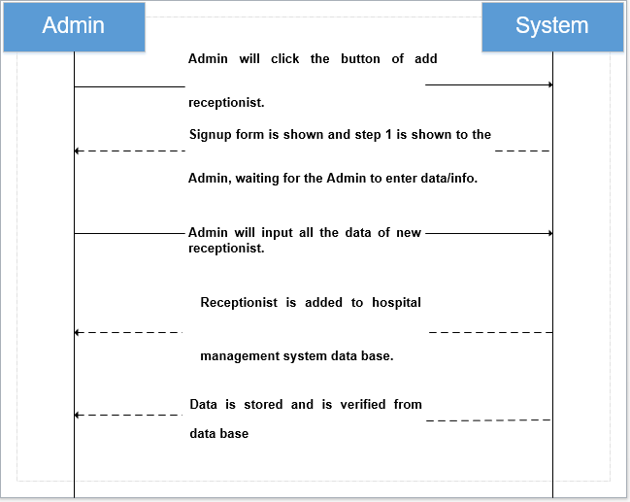

UC:15 Delete receptionist 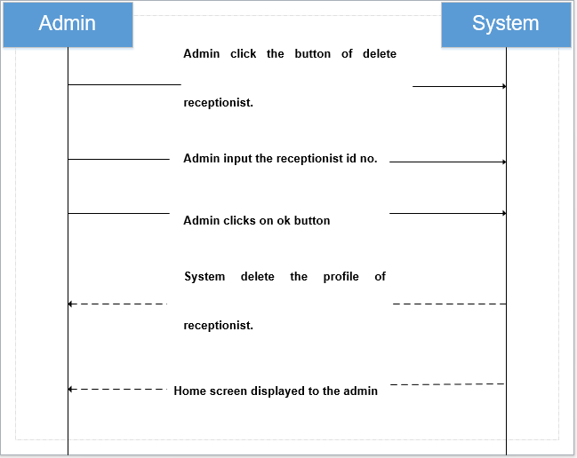

UC16 : Update info of Receptionist 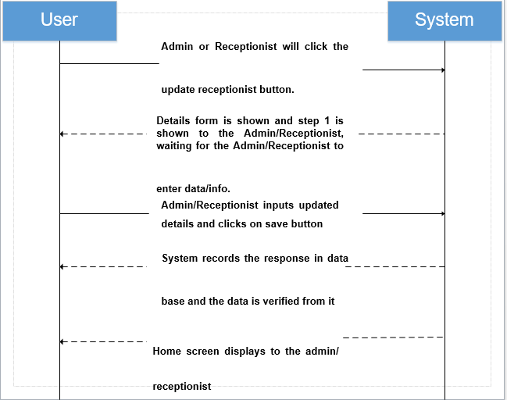
UC 17: Adding Patient (Outdoor)

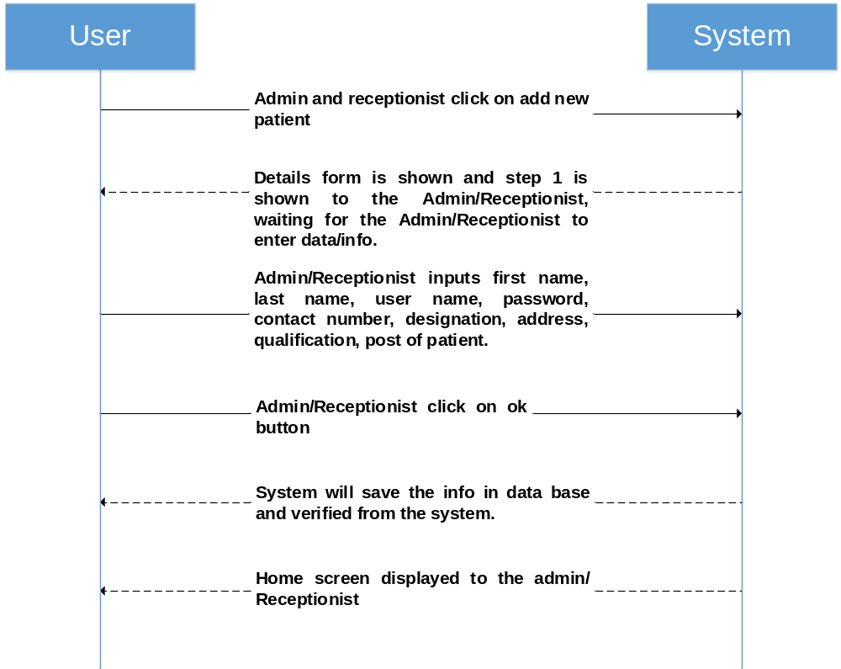

UC:18 Adding Patient (Indoor)

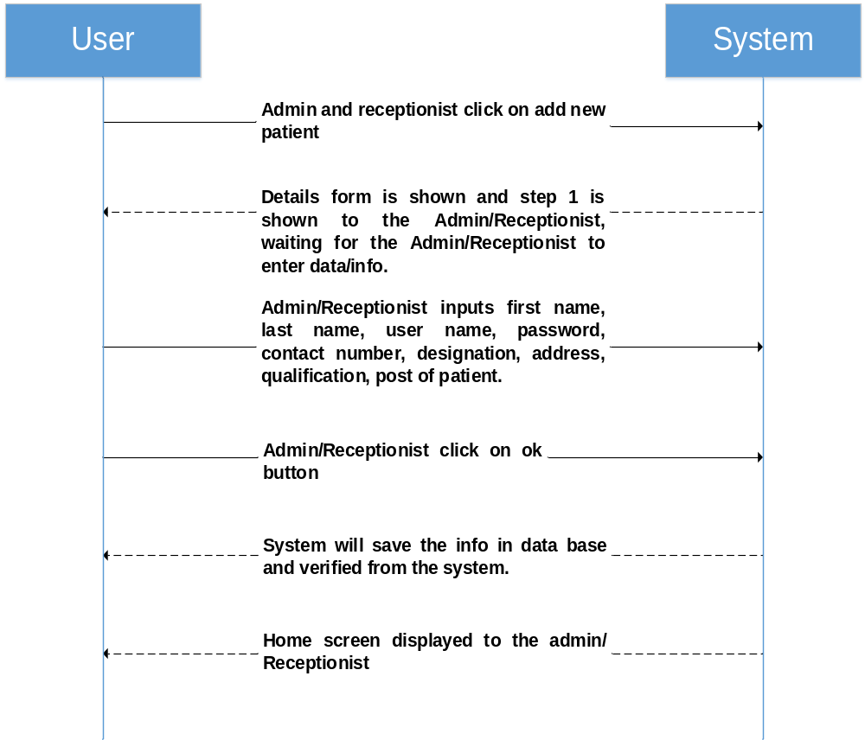
UC 19 : Delete Patient

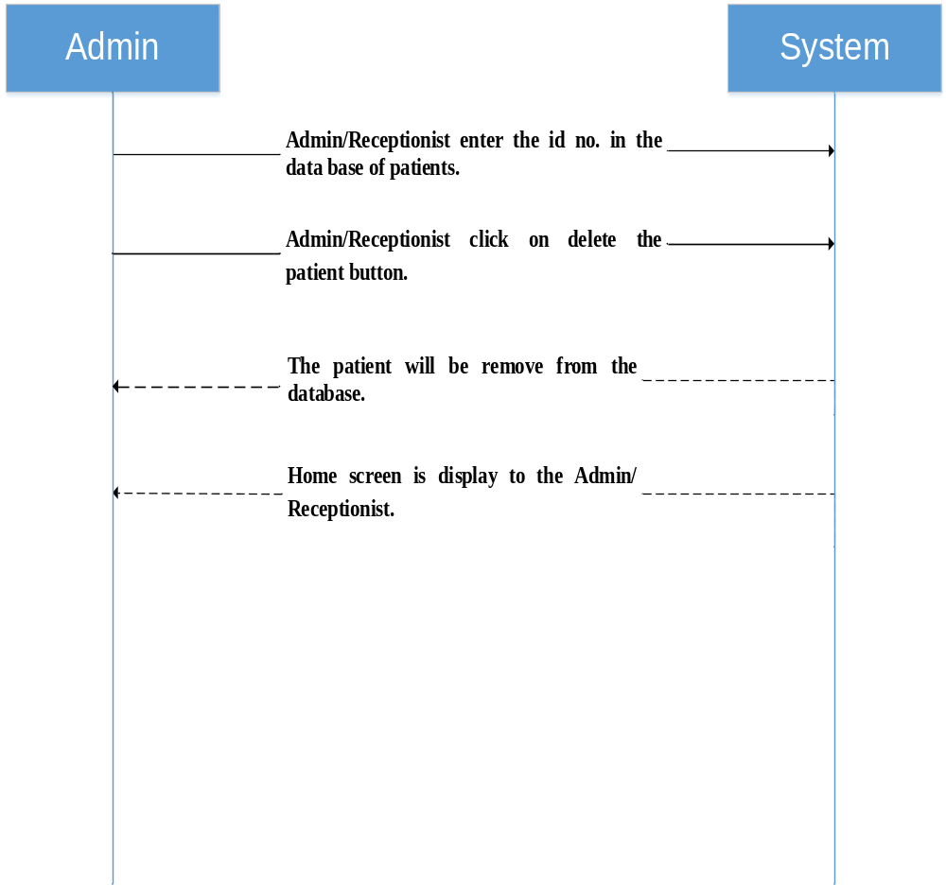

UC 20 : Update info of patient

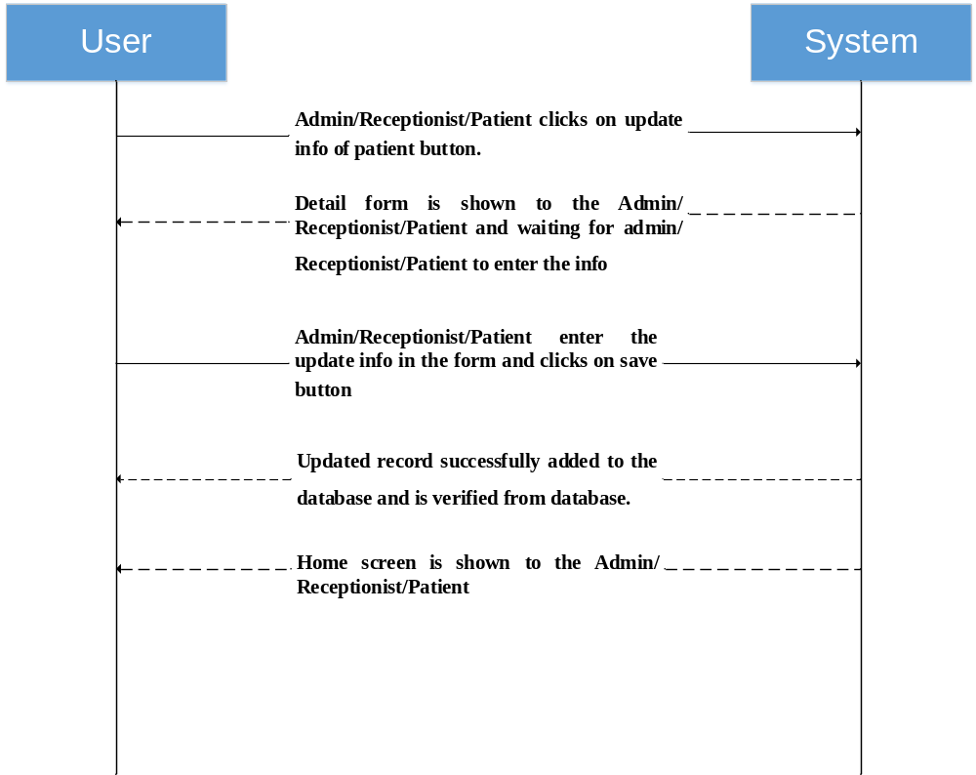

UC 21 : Print or view billing

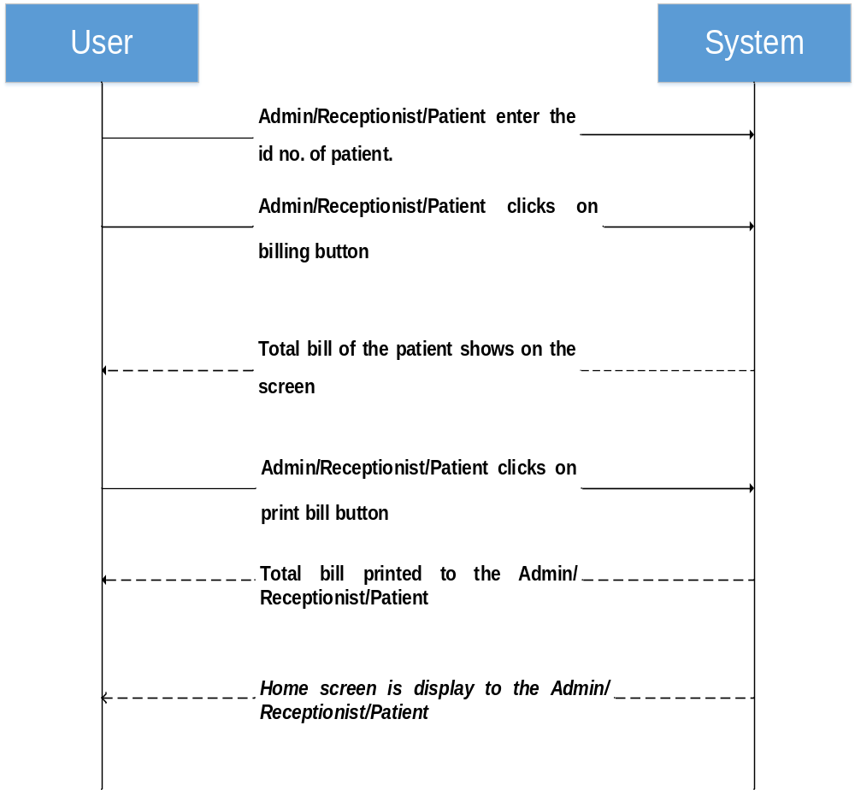

User Interface/ Story Board
This section may be used to provide screenshots of the application to give an idea of how the GUI will appear. Include Story Board.

Data Dictionary
This section may be used to provide the details of interface elements that are present on the screenshots.

Element Name | Type | Validation | Mandatory | Remarks

Conceptual Model
Draw your conceptual model after writing all your use cases. This is an optional section, which will be applicable when there are a large number of entities.
A Conceptual model is a representation of concepts in a problem domain. It is illustrated with a set of static structure diagrams. It can represent the following:
- Concepts
- Associations between concepts
- Attributes of concepts
A new example consistent with the Accounting System example used in this document should be provided.
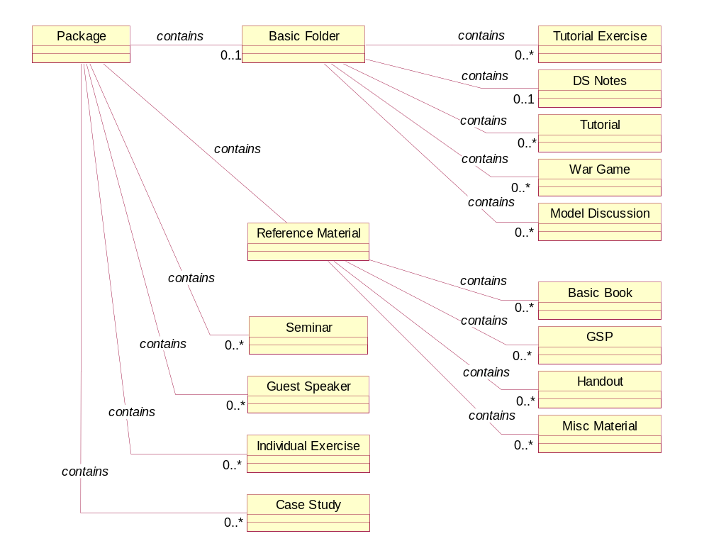
Figure 2 Conceptual Model
concept reacts differently to events depending on their state, it is considered as state-dependent concept or type. Create state diagrams only for state-dependent concepts with complex behavior.
A relevant example needs to be inserted here.

Glossary
A glossary or model dictionary lists and defines all the terms that require clarification in order to improve communication and reduce the risk of misunderstanding.
Record domain or business terms, rules, concepts, etc. in the glossary

 | Comments
DS | DS stands for Directing Staff, a class instructor
Div | Stands for a Division with fixed strength and organization
Package | ….

Index
The index is optional. If the document is made available in electronic form, readers can search for terms electronically.

Appendices
Include supporting detail that would be too distracting to include in the main body of the document.

